DISTANCE VECTOR ROUTING ALGORITHM IN C
Distance Vector Routing Algorithm C Program (distance_vector.c):
Code:
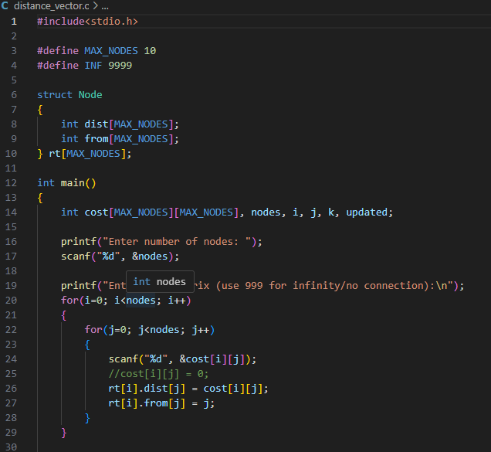
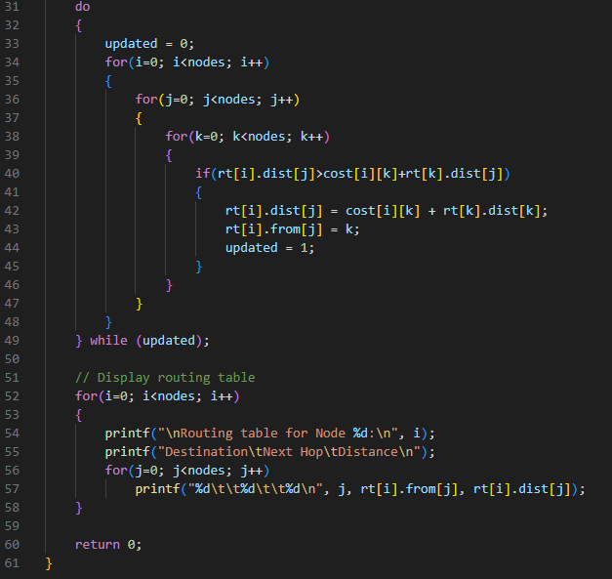

Output:




